**NEWS Letter Index**

* Vision/Mission of the institute
* Blooms Taxonomy /Graduate attributes

**Technical**

* Guest lecture
* Industrial Visits
* IndustryInstituteInteractions
* ResearchConsultancy
* Students' Technical Achievements
* Faculties' Technical Achievements
* Technical Events organised by institute / Department (Seminar/ Workshop / Quiz/ project Competition etc.)
* Placements
* Exam Conduction / Assessment (CA-I, II, Mid semester, End Semester)

**Social**

* Social Events organised by institute / Department (Tree Plantation / Blood Donation / NSS Activities / Waste Collection / No Vehicle Day etc.)

**Mentoring**

* Induction program
* Proctor Meet
* Parents Meet
* DAB Meet
* Alumni Meet

**Cultural**

* Freshers Function
* Send off Function
* Southard
* Cultural Club Activities
* Department Cultural Activities
* Students / Faculties Cultural Achievements

**Sports**

* Students / Faculties Sports Participation Achievements
* Vision/Mission of the institute

**Vision**

To be a reputed technological and management Institute imparting quality education and developing Core Human Values (H3).

(H3): Honest - Humble - Human Being

**Mission**

We are Committed for enrichment of the Institute to disseminating the knowledge to achieve Academic Excellence and develop industry ready Technical Manpower

* Blooms Taxonomy /Graduate attributes

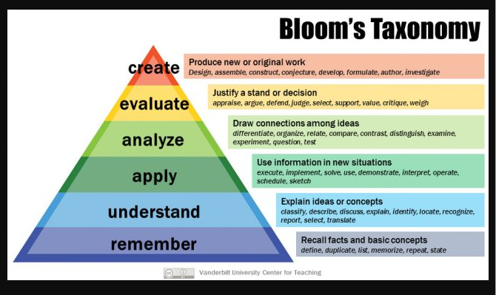

Graduate Attributes

1. Engineering knowledge.
2. Engineering Analysis.
3. Engineering Design.
4. Innovation.
5. Modern Tools.
6. Engineers and Society.
7. Environment and Sustainability.
8. Ethics.
9. Team work.
10. Oral (Communication Skills)
11. Management Skills.
12. Lifelong learning.
13. Economics ( KADI, MEET, TOMLE)

**Technical**

* Technical Events organised by institute / Department (Seminar/ Workshop / Quiz/ project Competition etc.)

|  |  |  |
| --- | --- | --- |
| Name of Technical Events  **EDC Workshop:-25/11/22** | | |
|  |  | |
| **EDC workshop** conducted in the Institute on **25/11/22** with Topic **“Personality Development”** conducted by Mr. Prashant Pupal (Ramakrishna Math Pune) Total 100 nos. of students participated in this workshop. | | |
| Name of Technical Events  **TPO Activity-** | | |
| D:\Mechanical Department documents\2022-23\Odd Sem Activities\IMG-20221221-WA0002.jpg | | D:\Mechanical Department documents\2022-23\Odd Sem Activities\IMG-20221221-WA0002.jpg |
| TPO activity conducted in the Institute from 13.12.22 to 16.12.22 with Topic **“Quantitative Aptitude and Logical reasoning”** conducted by the Trainers Mr. Shoaib Aattar and Mr. Adhik Sapkal. Total 64 nos.of students participated in the event. | | |

* Placements

|  |  |  |  |  |  |
| --- | --- | --- | --- | --- | --- |
| **Sr No** | **Students Name** | **Department** | **Year of Passing** | **Class** | **Company name and package** |
| **1** | **Ms. Varsha Rajput** | **Civil** | **2019-20** | **BE** | **TCS** |
| **2** | **Ms. Shraddha Nagarhalli** | **Civil** | **2020-21** | **B. Tech** |  |
| **3** | **Mr. Varad Jangam** | **Civil** | **2020-21** | **B. Tech** | **Studying in New York university [MSc. In Management** |
| **4** | **Mr. Prathamesh Joshi** | **Civil** | **2021-22** | **B. Tech** | **M. Tech at NIT NAgpur** |

Photo if AVAILABLE Details

|  |  |
| --- | --- |
| Ms. Varsha Rajput |  |
| Ms. Shraddha Nagarhalli |  |
| Mr. Varad Jangam |  |
| Mr. Prathamesh Joshi |  |

**Cultural**

* Freshers Function/Send off Function/Southard /Cultural Club Activities/ Department Cultural Activities

|  |
| --- |
| Name of Event: Navratri [ Khandenavmi Pujan] |
|  |
| The Navratri [ Khandenavmi Pujan] was celebrated on 4.10.2022 in Civil Engineering Department. |