Department of Civil Engineering

NEWS LETTER – 2022-2023
Volume 2022, Issue 2 (January 2023 - March 2023)
Sanjay Bhokare Group of Institutes added the Civil Engineering course in the year 2009. It is a 4-years (8 semesters) full time program duly approved by the AICTE Govt. of India. Shelter is one of the basic needs of human being and it is provided by Civil Engineering. Civil Engineering consists of Applied Mechanics, Structural Mechanics, Concrete Technology, Fluid Mechanics, Surveying, Engineering Geology, Geo-tech Engineering, Earthquake Engineering, Environmental Engineering and Transportation Engineering branches. Now days infrastructural development is very fast due to tremendous increase in the population. So civil engineers are highly demanded by the society and industry. The department has well-qualified and experienced faculty. All are post-graduates. The department is well equipped with spacious laboratories, which cater to testing of materials as well as academic needs. Since 2017 Civil Engineering Department is affiliating to Dr. Babasaheb Ambedkar Technological University, Lonere (DBATU).
Vision
" To be reputed Technological Civil Engineering Department imparting Advanced Engineering tools applicable for Industry & Society."
Mission
“To enrich the student’s ethics and core knowledge in Civil Engineering to meet the Civil Engineering Industry requirement.”

INSIDE THIS ISSUE
Technical Section
- Guest lecture
- Industrial Visits
- Industry Institute Interactions
- Research Consultancy
- Students' Technical Achievements
- Faculties' Technical Achievements
- Technical Events organised by institute / Department (Seminar/ Workshop / Quiz/ project Competition etc.)
- Placements
- Exam Conduction / Assessment (CA-I, II, Mid semester, End Semester)
Social Section
- Social Events organised by institute / Department (Tree Plantation / Blood Donation / NSS Activities / Waste Collection / No Vehicle Day etc.)
Mentoring Section
- Induction program
- Proctor Meet
- Parents Meet
- DAB Meet
- Alumni Meet
Cultural Section
- Freshers Function
- Send off Function
- Southard
- Cultural Club Activities
- Department Cultural Activities
- Students / Faculties Cultural Achievements
Sports Section
- Students / Faculties Sports Participation Achievements
Other Activities
- Any other new activities

- Industry Institute Interactions
Sr. No. | Faculty Name | Department | Details
1 | Mrs. S. M. Madhale | Civil Engineering | Visit to Dr. J. J. Magdum College of Engineering, Jaysingpur for preparation of NAAC Mock Visit

- Faculty Technical Achievements
Sr. No. | Faculty Name | Department | Details
1 | Mrs. P. P. Kamble | Civil Engineering | Prof. Mrs. P. P. Kamble book published  LAMBERT ISBN-978-620-6-14595-0
2 | Mrs. A. S. Pachore | Civil Engineering | Prof. Miss. A. S. Pachore book published  LAMBERT ISBN-978-620-6-14669-8

- Exam Conduction / Assessment (CA-I, II, Mid semester, End Semester)
- Exam Conduction / Assessment in Civil Engineering is done accordance with internal exam Policy
Social
EVENT 1
Name of Event: “Celebration of Savitribai Phule Birth Anniversary as a BALIKA DIN”
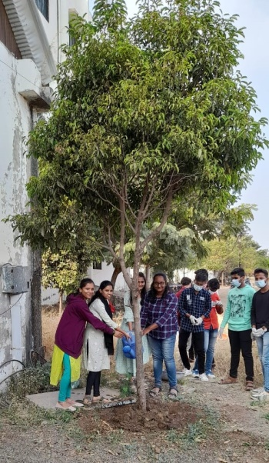
Tree Plantation done by Department girls on the occasion of Savitribai Phule Jayanti as Balika Din
Sports
- Students' Sports Achievements
Sr. No. | Students Name | Class | Department | Details
1 | Uday Patil | Final year B. Tech. | Civil Engineering | Carrom Single Runner-up [02/03/2023]
2 | Majid Mulla | S. Y.  B. Tech. | Civil Engineering | Carrom Single Winner [02/03/2023]
3 | Sandesh More | Final year B. Tech. | Civil Engineering | Carrom Doubles Runner-up [02/03/2023]
4 | Akash Patil | Final year B. Tech. | Civil Engineering | Carrom Doubles Runner-up [02/03/2023]
5 | Nikam Girish | Final year B. Tech. | Civil Engineering | 100 m Running Winner [02/03/2023]  200 m Running Winner [02/03/2023]  400 m Running Winner [02/03/2023]  Disc Throw Runner-up [02/03/2023]  Short-Put Throw Winner [02/03/2023]  Javelin Throw Winner [02/03/2023]
6 | Sanjana Chougule | T. Y.  B. Tech. | Civil Engineering | Badminton Doubles Winner [05/03/2023]  Kabbadi Winner [04/03/2023]
7 | Vaishanvi Rajput | T. Y.  B. Tech. | Civil Engineering | Kabbadi Winner [04/03/2023]
8 | Bhagyashri Jamdade | T. Y.  B. Tech. | Civil Engineering | Badminton Doubles Winner [05/03/2023]  Kabbadi Winner [04/03/2023]
 | Prajwal Mali,  Viraj Patil,  Sufiyan Nipanikar,  Sanjana Chougule, Vaishanvi Rajput,  Bhagyashri Jamdade, | S. Y. & T. Y.  B. Tech. | Civil Engineering | Souhard 2023 Dance Competition Runner-up

